## KENDRIYA VIDYALAYA MALDA

SESSION 2021-22

COMPUTER SCIENCE PROJECT

**NAME: KRISHNENDU BISWAS**

**CLASS: XII (SCIENCE)**

**ROLL NO.: 12682650**

**TOPIC: SCHOOL MANAGEMENT SYSTEM**

**GUIDE TEACHER: MR. TANMAY SUHANE, P.G.T. (C.S.)**

______________ _______________ ________________ _______________

External Sign Internal Sign Principal Sign Parent’s Sign



## TABLE OF CONTENTS

* CERTIFICATE

## ACKNOWLEDGEMENT

* CODING

## SCREENSHOTS

* REQUIREMENTS

## BIBLIOGRAPHY

ACKNOWLEDGEMENT

*I would like to express my deep sense of thanks and gratitude to my project guide Mr. Tanmay Suhane, PGT (Computer Science) for guiding me immensely through the course of the project. He always showed a keen interest in my project. His constructive advice and constant motivation have been responsible for the successful completion of this project. My sincere thanks go to Md. Mohamuddin, our principal sir for his co- ordination in extending every possible support for the successful completion of this project. I also thank my parents for encouraging me during the course of this project and for their constant support. I would also like to thank my classmates for their timely help and support for the completion of this project. Finally, I would like to thank CBSE for giving me this opportunity to undertake this project.*

Krishnendu Biswas

XII SCIENCE

## CERTIFICATE

#### This is to certify that Krishnendu Biswas of Class XII-Science, Kendriya Vidyalaya, Malda has successfully completed his project entitled ‘SCHOOL MANAGEMENT SYSTEM’. The report is a result of his efforts and endeavors.

*The report is found as worthy of acceptance as the final project report for the* ***Practical Report of Term-2 Practical Examination*** *(Computer Science) as prescribed by CBSE in the year 2021-22. The project report is prepared under my guidance.*

##### Date:

*Roll No.:*

##### Signature of Signature of School Examiner Principal

**_**



* CODIng



# importing mysql.connector to use MySQL for storing data of students, teachers, etc. import mysql.connector as a

# establishing connection with MySQL local server

con = a.connect(host="localhost", user="root", passwd="1631", database="school2")

#importin OS module for clear screen func import os

"""

Creating a MySQL Database

1. Download and install MySQL **/
2. Using the MySQL Command Line Client execute the following commands(line 8 to 15):

# create database school; # use school;

# create table student (name varchar(50), class varchar(20), roll varchar(10),

address varchar(50), phone varchar(10));

# create table teacher (name varchar(50), post varchar(20), salary varchar(10),

address varchar(50), phone varchar(10), acno varchar(10));

# create table cattendance (date varchar(20), class varchar(10), absent varchar(1000));

# create table tattendance (date varchar(20), absent varchar(1000));

# create table fees (name varchar(50), class varchar(20), roll varchar(10),

month_year varchar(20), fees_rs varchar(20), date varchar(20));

# create table salary (name varchar(50), month varchar(20), paid varchar(20));

"""

# ~~~~~~~~~Function to Add a Student~~~~~~~~~ def ast():

os.system('cls')

print(">- -<") n = input("Student Name: ")

c = input("Class Name: ") r = input("Roll No: ")

ad = input("Address: ") p = input("Phone: ") data = (n, c, r, ad, p)

sql = 'insert into student values(%s,%s,%s,%s,%s)'

c = con.cursor() c.execute(sql, data) con.commit()

print("Data Entered Successfully")

print(">- -<") choice = input("press enter to exit/press m to go back to main menu: ")

if choice == "M" or choice == "m": main()

else:

exit()

# ~~~~~~~~~Function to Remove a Student~~~~~~~~~

def rst():

os.system('cls')

print(">- -<") c = input("Class Name: ")

r = input("Roll No: ") data = (c, r)

sql = 'delete from student where CLASS = % and ROLL = %s'

c = con. cursor() c.execute(sql, data) con.commit() print("Data Updated")

print(">- -<") choice = input("press enter to exit/press m to go back to main menu: ")

if choice == "M" or choice == "m": main()

else:

exit()

# ~~~~~~~~~Function to Add a Teacher~~~~~~~~~ def addt():

os.system('cls')

print(">- -<") n = input("Teacher Name: ")

p = input("Post: ")

s = input("Salary: ") ad = input("Address: ") ph = input("Phone: ") ac = input("Account: ")

data = (n, p, s, ad, ph, ac)

sql = 'insert into teacher values(%s,%s,%s,%s,%s,%s)'

c = con.cursor() c.execute(sql, data) con.commit()

print("Data Entered Successfully")

print(">- -<") choice = input("press enter to exit/press m to go back to main menu: ")

if choice == "M" or choice == "m": main()

else:

exit()

# ~~~~~~~~~Function to Remove a Teacher~~~~~~~~~ def remt():

os.system('cls')

print(">- -<") n = input("Teacher Name: ")

ac = input("Account: ") data = (n, ac)

sql = 'delete from teacher where name = %s and acno = %s'

c = con.cursor() c.execute(sql, data) con.commit() print("Data Updated")

print(">- -<") choice = input("press enter to exit/press m to go back to main menu: ")

if choice == "M" or choice == "m": main()

else:

exit()

# ~~~~~~~~~Function to List Absent Students from different classes~~~~~~~~~

def abclass():

print(">- -<")

d = input("Date: ") cl = input("Class: ")

ab = input("Names of Absent Students: ") data = (d, cl, ab)

sql = 'insert into cattendance values(%s,%s,%s)'

c = con.cursor() c.execute(sql, data) con.commit() print("Data Updated")

print(">- <") choice = input("press enter to exit/press m to go back to main menu: ")

if choice == "M" or choice == "m": main()

else:

exit()

# ~~~~~Function to List Absent Teachers~~~~~

def abteacher(): os.system('cls') print(">

d = input("Date: ")

ab = input("Names of Absent Teachers: ") data = (d, ab)

sql = 'insert into tattendance

<")

values(%s,%s)' c = con.cursor() c.execute(sql, data) con.commit() print("Data Updated")

print(">- -<") choice = input("press enter to exit/press m to go back to main menu: ")

if choice == "M" or choice == "m": main()

else:

exit()

# ~~~~~~~~~Function for Submitting Fees~~~~~~~~~ def submitf():

os.system('cls')

print(">- -<") n = input("Student Name: ")

c = input("Class Name: ") r = input("Roll No: ")

m = input("Month and Year: ") f = input("Fees: ")

d = input("Date: ")

data = (n, c, r, m, f, d) sql = 'insert into fees

values(%s,%s,%s,%s,%s,%s)' c = con.cursor()

c.execute(sql, data) con.commit() print("Fees Submitted")

print(">- -<") choice = input("press enter to exit/press m to go back to main menu: ")

if choice == "M" or choice == "m": main()

else:

exit()

# ~~~~~Function to Pay Teacher's Salary~~~~~ def pays():

os.system('cls')

print(">- -<") n = input("Teacher Name: ")

m = input("Month: ") p = input("Yes/No? ") data = (n, m, p)

sql = 'insert into salary values(%s,%s,%s)' c = con.cursor()

c.execute(sql, data) con.commit()

print("Data Entered Successfully")

print(">- -<") choice = input("press enter to exit/press m to go back to main menu: ")

if choice == "M" or choice == "m": main()

else:

exit()

# ~~~~~~~~~Function to Display the profile all the Students of a particular Class~~~~~~~~~

def dclass():

os.system('cls')

print(">- -<") cl = input("Class: ")

data = (cl,)

sql = "select * from student where class =

%s"

c = con.cursor() c.execute(sql, data) d = c.fetchall()

for i in d:

print(">- <") print("Name: ", i[0])

print("Class: ", i[1])

print("Roll No.: ", i[2])

print("Address: ", i[3])

print("Phone: ", i[4])

print(">- <")

print(">- -<") choice = input("press enter to exit/press m

to go back to main menu: ")

if choice == "M" or choice == "m": main()

else:

exit()

# ~~~~~~~~~Function to Display the profile of

all the Teachers~~~~~~~~~~~~~~~~~

def dteacher(): os.system('cls')

print(">- -<") sql = "select * from teacher"

c = con.cursor() c.execute(sql)

d = c.fetchall() for i in d:

print(">- <")

print("Name: ", i[0])

print("Post: ", i[1])

print("Salary: ", i[2])

print("Address: ", i[3])

print("Phone: ", i[4]) print("Account Number: ", i[5]) print(">- <")

print(">- <") choice = input("press enter to exit/press m

to go back to main menu: ")

if choice == "M" or choice == "m": main()

else:

exit()

# ~~~~Function to Check Student Fees Report~~~~ def feesreport():

os.system('cls')

print(">- -<") cl = input("Class: ")

data = (cl,)

sql = "select * from fees where class = %s" c = con.cursor()

c.execute(sql, data) d = c.fetchall()

for i in d:

print(">- <") print("Name: ", i[0])

print("Class: ", i[1])

print("Roll No.: ", i[2])

print("Month & Year: ", i[3])

print("Fees: ", i[4])

print("Date: ", i[5])

print(">- <")

print(">- -<") choice = input("press enter to exit/press m to go back to main menu: ")

if choice == "M" or choice == "m": main()

else:

exit()

# ~~~~~~~~~Function to Check if a Teacher's

Salary is paid or not~~~~~~~~~~~~~~

def checkteachsal(): os.system('cls')

print(">- ") name = input("Teacher's Name: ")

data = (name,)

sql = "select * from salary where name = %s" c = con.cursor()

c.execute(sql, data) d = c.fetchall()

for i in d:

print(">- <") print("Teacher's Name: ", i[0])

print("Month: ", i[1]) print("Transaction Completed? ", i[2]) print(">- <")

print(">- -<") choice = input("press enter to exit/press m to go back to main menu: ")

if choice == "M" or choice == "m": main()

else:

exit()

# ~~~~~~~~~Function to Display all the absent students on a particular date~~~~~~~~~

def dabstud(): os.system('cls')

print(">- -<") date = input("Date: ")

data = (date,)

sql = "select * from cattendance where date

= %s"

c = con.cursor() c.execute(sql, data) d = c.fetchall()

for i in d:

print(">- <") print("Class: ", i[1])

print("Name of Absent Students: ", i[2]) print(">- <")

print(">- -<") choice = input("press enter to exit/press m

to go back to main menu: ")

if choice == "M" or choice == "m": main()

else:

exit()

# ~~~~~~~~~Function to Display all the absent teachers on a particular date~~~~~~~~~~

def dabteach(): os.system('cls')

print(">- -<") date = input("Date: ")

data = (date,)

sql = "select * from tattendance where date

= %s"

c = con.cursor() c.execute(sql, data) d = c.fetchall()

for i in d:

print(">- <") print("Name of Absent Teachers: ", i[1]) print(">- <")

print(">- -<") choice = input("press enter to exit/press m to go back to main menu: ")

if choice == "M" or choice == "m": main()

else:

exit()

# ~~~~~~~~~Main Function~~~~~~~~~ def main():

os.system('cls')

# ~~~~~~~~~~~~~~SchoolBanner~~~~~~~~~~~~~~~~ print("""

|  |  |  |  |  |  |  |
| --- | --- | --- | --- | --- | --- | --- |
| ### | ### | ### | | ### | | ############## |
| ### | ### | ### | | ### | | ### |
| ### | ### | ### | | ### | | ### |
| ### | ### | ### | | ### | | ### |
| ####### ### ### ### ###  ### ### | | ### | ###  ###  ###  ### | ### ###  ###  ### | ### | #############  ###  ###  ### |
| ### | ### | ### | #### | | ### | ############## |

""")

#~~~~~~~~~~~~~~~~~~~~~~~~~~~~~~~~~~~~~~~~~~~~~~~

#~~~~~~~~~~~~~~~~~~~~~MENU~~~~~~~~~~~~~~~~~~~~~~ print("""

+ SCHOOL MANAGEMENT SOFTWARE +

| Menu |

| | |

| >[1] Add Student | >[2] Remove Student |

| >[3] Add Teacher | >[4] Remove Teacher |

| >[5] Class Attendance | >[6] Teacher Attendance |

| >[7] Submit Fees | >[8] Pay Teacher's Salary |

| >[9] Display Profiles of all the | >[10] Display Teachers' Profiles |

| Students in a Particular | |

| Class | |

| >[11] Check Fee Submission | >[12] Check if a Teacher's Salary |

| | is paid or not |

| >[13] Display Absent Students | >[14] Display Absent Teachers |

| >[15] Exit | |

+ +

""")

#~~~~~~~~~~~~~~~~~~~~~~~~~~~~~~~~~~~~~~~~~~~~~~~ # ~~~~Taking the response from the user~~~

choice = int(input(" >>> What would you like to do? "))

if choice == 1: ast()

elif choice == 2: rst()

elif choice == 3: addt()

elif choice == 4: remt()

elif choice == 5: abclass()

elif choice == 6: abteacher()

elif choice == 7:

submitf() elif choice == 8:

pays()

elif choice == 9: dclass()

elif choice == 10: dteacher()

elif choice == 11: feesreport()

elif choice == 12: checkteachsal()

elif choice == 13: dabstud()

elif choice == 14: dabteach()

elif choice == 15: exit()

else:

print("Wrong choice!") main()

#~~~~~~~~~~~~~~~~~~~~~~~~~~~~~~~~~~~~~~~~~~~

# ~~~~~~~~~Executing the main function~~~~~~~~~ main()

# ~~~~~~~~~~~~~~~~~~~~~~~~~~~~~~~~~~~~~~~~~~~~~~



# SCREENSHOTS.

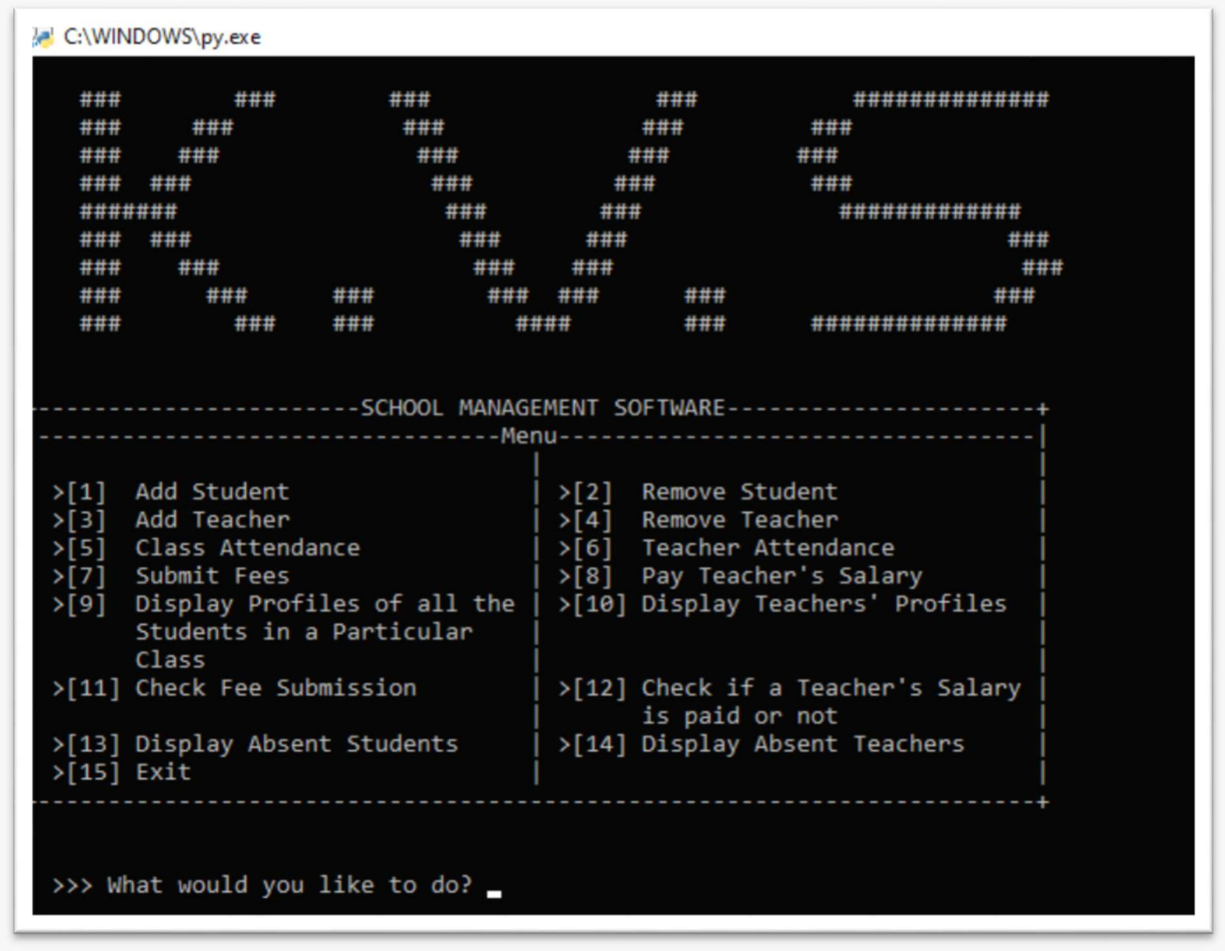

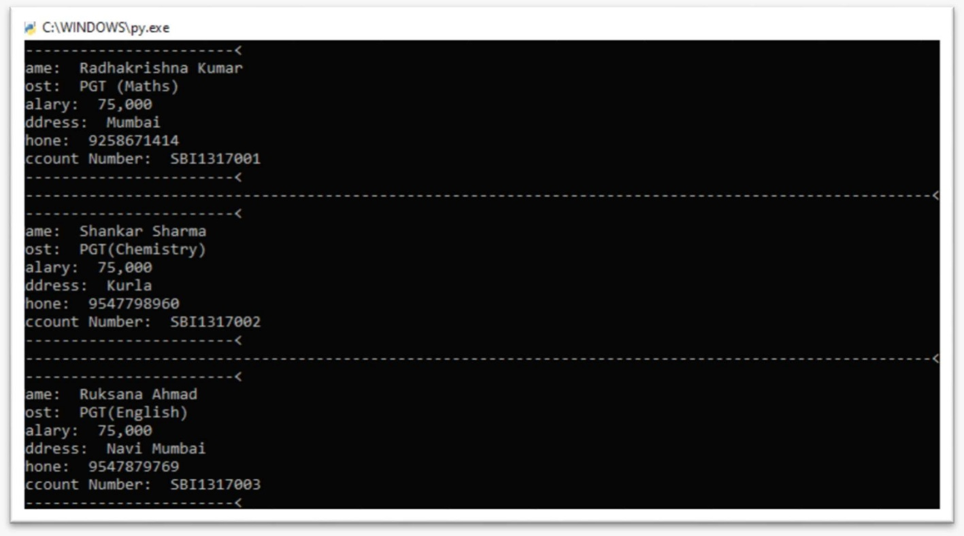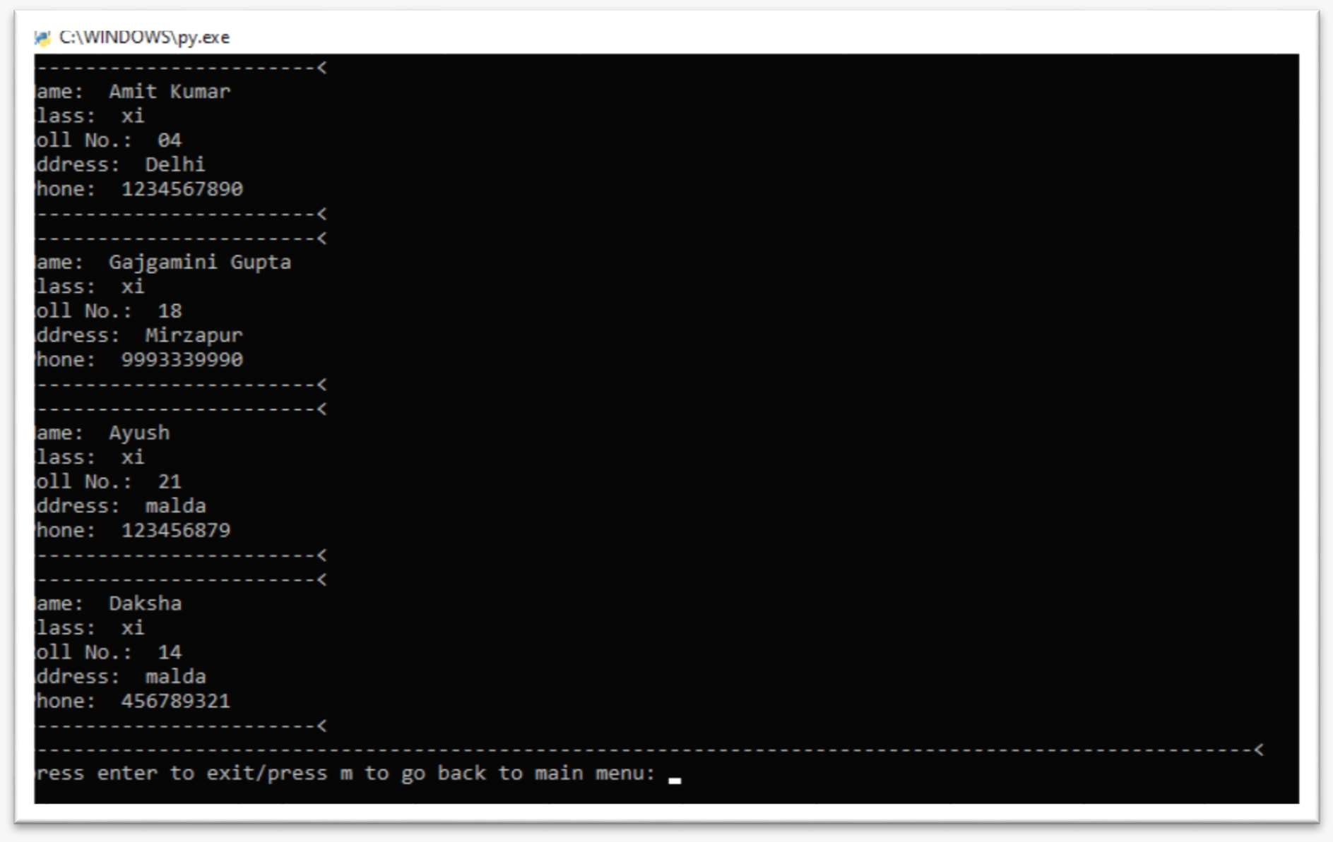

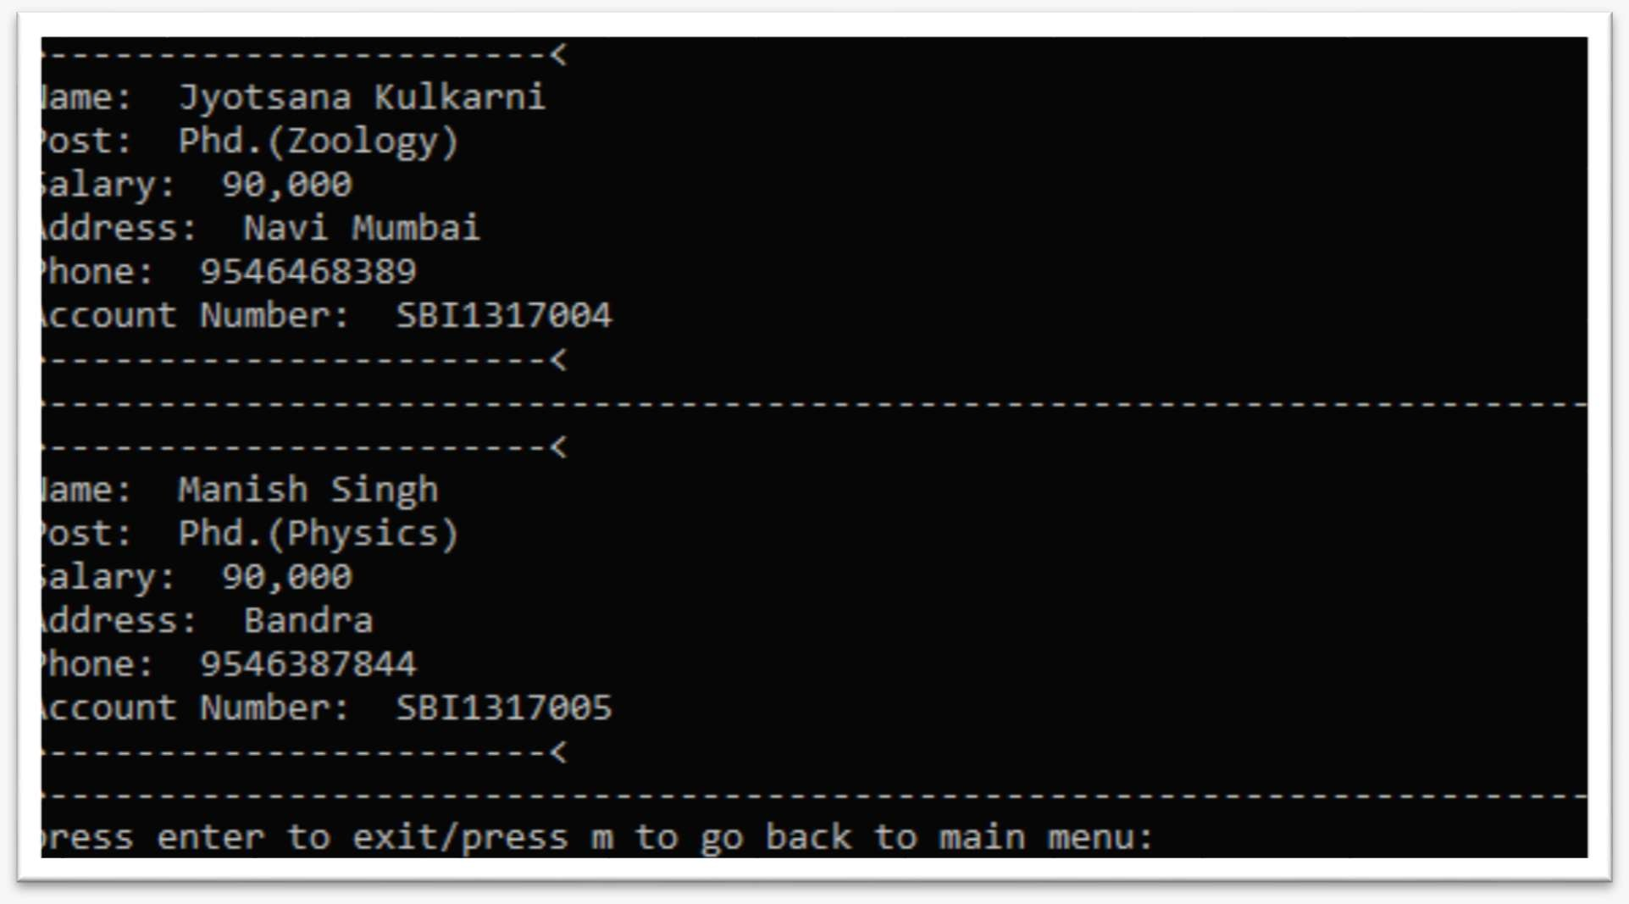

REQUIREMENTS

### HARDWARE REQUIRED

* Printer, to print the required documents of the project

### Compact Drive

* *Processor:* - *Core i3 4th gen*
* *Ram:* - *512* MB
* *Hard-disk:* - *20* GB*.*

### SOFTWARE REQUIRED

* *Operating system* (MINIMUM): - *Windows XP*
* *Python IDLE-3.x or PyCharm*
* *MySQL Shell* (DBMS)
* *Notepad:* - for writing the data in a file*.*

# BIBLIOGRAPHY

 Computer Science with Python: -

Sumita Arora

 python.org

 w3schools.com

 stackoverflow.com  geeksforgeeks.org scribd.com

 GitHub link for program source code: -

https://github.com/imKrishn/SchoolManagmentSystemXIICS